2025 Software testing project (STP)

Using the JavaParser Library for Parsing OO Java Code and Manipulating the Abstract Syntax Tree (AST)

Nastaran Sarkhosh

*dept. of Software Engineering University of Isfahan*

Isfahan, Iran [sarkhoshnastaran@gmail.com](mailto:m.khorsandi@mehr.ui.ac.ir)

Mohammad Amin Kiani

*dept. of Software Engineering University of Isfahan*

Isfahan, Iran [aminkiani82@gmail.com](mailto:saei.alireza@mehr.ui.ac.ir)

Yazdan Afra *dept. of Software Engineering University of Isfahan*

Isfahan, Iran y[azdanAfra93@gmail.com](mailto:m.sharbaf@eng.ui.ac.ir)

***Abstract*—** **Mutation testing is a powerful technique used to evaluate the robustness and effectiveness of software test suites. This method involves introducing small, controlled modifications, known as mutations, into the source code of the software under test (SUT). An effective test suite is expected to identify and detect these artificially injected changes. The critical aspect of mutation testing lies in ensuring that the mutated code remains syntactically and semantically valid, avoiding compilation or runtime errors. The effectiveness of this approach depends significantly on the precision and contextual relevance of the applied mutations. This paper presents a novel methodology that leverages the Abstract Syntax Tree (AST), generated using the JavaParser library, to perform precise, automated, and context-aware mutations. By traversing the AST, our approach identifies target nodes representing key program constructs and applies transformations directly to these nodes, ensuring syntactic correctness. These transformations range from modifying access modifiers to altering method names or reordering statements within constructors. Unlike traditional string-based code manipulation, our method benefits from the structured representation of the AST, minimizing errors and enhancing scalability. To address potential issues in maintaining the syntactic and semantic integrity of the mutated code, our approach ensures that modifications respect the inherent structure and dependencies of the program. By automating mutation generation and guaranteeing code validity, this methodology enhances the accuracy, flexibility, and efficiency of mutation testing, making it a reliable tool for software quality assessment.**

**Keywords—Software Testing, Mutation Testing, Abstract Syntax Tree (AST), JavaParser, Automated Code Mutation.**

1. Introduction

Ensuring the reliability of software systems remains one of the most critical and challenging goals in the field of software engineering [1]. Among the various techniques for evaluating and improving test suites, mutation testing has emerged as one of the most effective methods. This technique involves injecting artificial faults into the software under test (SUT) to create modified versions of the program, referred to as mutants. Each mutant contains a single artificial fault, and the test suite is executed against these mutants. An effective test suite is expected to detect and "kill" all mutants, ensuring comprehensive coverage of potential fault scenarios. If any mutants remain undetected, the test suite can be refined to address those weaknesses, resulting in a more reliable system [2]. A common way to introduce these artificial faults is through mutation operators—predefined rules designed to inject faults at specific locations in the code. While generic mutation operators are widely used, they often generate a high number of irrelevant or trivial mutants that do not effectively challenge the test suite. Additionally, mutation operators need to be tailored to the syntax and semantics of each programming language, making them less flexible and more difficult to adapt across different contexts. More importantly, generic approaches may lack the ability to target specific areas of the codebase that are more prone to faults or critical for system functionality, thereby reducing their effectiveness [3]. A more targeted approach to mutation testing focuses on specific fault types or critical areas of the code, addressing weaknesses in the test suite with greater precision. This method enables the generation of meaningful and context-aware mutants while reducing redundancy and improving the efficiency of the mutation testing process. Such an approach can also be customized to align with the unique requirements and coding patterns of specific projects, making the results more actionable and relevant [4]. In this paper, we present a novel approach to mutation testing that leverages Abstract Syntax Trees (AST), generated using the JavaParser library, to introduce syntactically valid and context-aware mutations. Unlike traditional mutation techniques, our approach directly manipulates the AST representation of the SUT, enabling precise and flexible fault injection at various levels of granularity. By traversing the AST, we identify key program constructs and apply controlled transformations, such as modifying access modifiers, altering method names, or reordering statements, while ensuring that the resulting mutants remain syntactically and semantically valid. This method minimizes errors and enhances the scalability and adaptability of the mutation testing process. To evaluate our approach, we provide a proof-of-concept implementation for Java programs. Our method ensures that mutations respect the structural integrity and dependencies of the original code while maintaining the ability to customize mutation rules to meet project-specific requirements. The results demonstrate that leveraging AST-based transformations not only improves the precision and relevance of generated mutants but also enhances the overall efficiency of the mutation testing process. The rest of this paper is organized as follows: Section II reviews the theoretical background and related works. Section III introduces the details of our AST-based mutation testing methodology. Section IV evaluates the proposed approach using a proof-of-concept implementation and discusses its advantages. Finally, Section V concludes the paper and suggests directions for future research.

1. Related Work

Mutation testing has been extensively studied and developed to systematically introduce artificial faults into software, aiding in the evaluation of test suite effectiveness. This section outlines key approaches to mutation testing and highlights the relevance of Abstract Syntax Trees (AST) and JavaParser in advancing this domain.

1. *Syntax-Driven Mutation Testing*

Syntax-driven mutation focuses on introducing faults by applying transformations based on the syntactic structure of source code. Traditional methods rely on predefined mutation operators targeting programming constructs like variables, operators, and control statements [5]. Examples include class-level, method-level, and integration-level mutation operators, which can be tailored to specific testing goals. However, such approaches often face challenges in generating meaningful or diverse mutants due to their reliance on static rules. By leveraging tools like JavaParser to parse and analyze the AST of a program, recent studies have enabled more granular and context-aware mutations, improving the accuracy and utility of syntax-driven mutation testing [6].

1. *Context-Aware AST Mutation*

AST-based mutation takes a more sophisticated approach by directly manipulating the hierarchical structure of source code. This technique provides finer control over the mutation process by targeting specific AST nodes, such as expressions, statements, or method declarations, rather than relying solely on surface-level syntax [7]. By using tools like JavaParser, it becomes possible to identify and modify precise locations within the AST, ensuring that mutations preserve the syntactic correctness of the program. This method addresses common limitations of traditional syntax-driven mutation, such as redundant mutants or invalid code, and enhances the overall fault-detection capabilities of test suites.

1. *Semantic-Preserving Mutations*

Beyond syntactic correctness, semantic-preserving mutations aim to introduce changes that maintain valid program behavior while creating subtle deviations. This approach is particularly useful for assessing a test suite's ability to detect nuanced behavioral faults. Utilizing AST analysis enables deeper insights into code dependencies and variable scopes, ensuring that mutations are both meaningful and executable [8]. JavaParser facilitates this process by providing detailed semantic context through its node-specific information, which can be utilized to generate mutations that reflect realistic fault scenarios.

1. *Intermediate Representation (IR) Mutation*

In addition to source code-level mutation, recent advancements have explored fault injection at intermediate representations, such as Java bytecode or LLVM IR. IR-level mutation benefits from platform independence and the ability to target optimized or compiled versions of code [9]. However, this approach often requires specialized tools and a deeper understanding of compiler internals. AST-based methods, such as those implemented using JavaParser, bridge the gap between high-level syntax mutation and low-level IR manipulation by offering detailed insights into the source code's structural and logical aspects.

1. *Evolutionary Mutation Technique*

Evolutionary approaches leverage advanced algorithms, such as genetic programming, to optimize the generation of mutants dynamically. By analyzing the AST of a program, these methods can iteratively refine mutations to maximize fault detection while minimizing redundant or trivial changes [10]. Integrating JavaParser into this process enables automated extraction and manipulation of code features, significantly improving the efficiency of evolutionary mutation testing techniques.

1. *Extreme Mutation Testing*

Extreme mutation involves drastic changes, such as removing entire methods or replacing complex expressions with simple constructs, to evaluate the robustness of test suites. While this technique provides insights into high-level test coverage, it often sacrifices precision for simplicity [11]. AST manipulation using JavaParser enhances extreme mutation by allowing selective modifications at varying levels of granularity, providing a balance between mutation extremity and contextual relevance.

1. Approach

This study introduces a novel mutation testing approach that leverages Abstract Syntax Trees (ASTs) to achieve precise and customizable fault injection in the software under test (SUT). By utilizing JavaParser to analyze and manipulate the AST, this method facilitates targeted mutation of specific code elements while ensuring syntactic and semantic correctness. The proposed approach is outlined in Figure 1, which summarizes the process of mutation generation and application.

1. *AST Construction*

The first step of the approach involves parsing the SUT's source code using a robust AST generation tool, such as JavaParser. Unlike parse trees, ASTs abstract away unnecessary syntactic details while retaining essential structural and hierarchical information about the code. Each node in the AST represents a distinct language construct, such as a class, method, or statement. This representation enables precise identification of mutation targets while maintaining a high-level understanding of the program’s structure.

1. *Mutation Target Identification*

Once the AST is constructed, specific nodes are selected for mutation. Nodes in the AST correspond to logical segments of the code, such as method calls, variable assignments, or control flow structures. By navigating the AST hierarchy, it is possible to pinpoint and isolate code segments that are particularly relevant for testing.  
The granularity of mutations can be controlled by selecting nodes at varying depths within the AST. For example, mutating a node at a higher level (e.g., an entire method) results in broader changes, whereas deeper nodes (e.g., a single operator or literal) allow for more fine-grained modifications. This flexibility is crucial for tailoring the mutation process to specific testing objectives or project requirements.

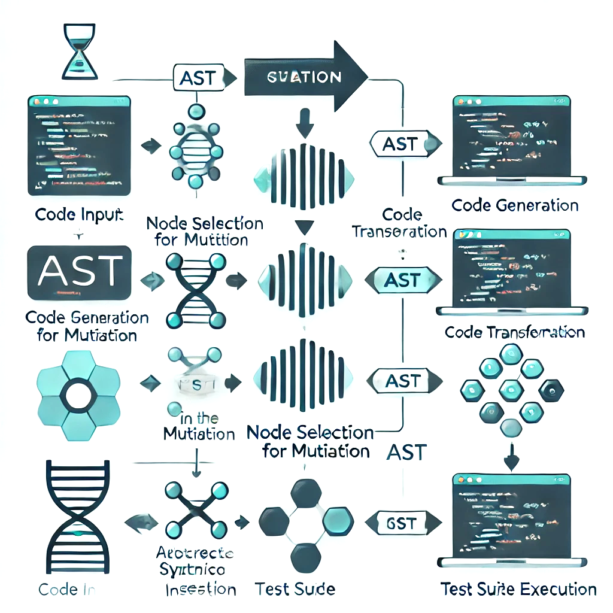

Fig. 1. mutation testing process using Abstract Syntax Trees (AST)

1. *Code Transformation*

After identifying a target node, the corresponding code segment in the original source code is extracted. Using the JavaParser framework, this segment can be replaced with a modified version that introduces a fault. The modifications are performed directly on the AST, ensuring that the resulting code remains syntactically valid. Common transformations include altering operators, changing variable values, or introducing erroneous method calls.

1. *Semantic Validation*

To ensure that the mutated code remains semantically meaningful, additional checks are performed. For example, variable names must be consistent with the existing scope and type constraints. The JavaParser library provides tools for analyzing symbol tables and resolving types, which can be used to validate and refine mutations. Placeholder tokens may also be employed during the transformation process to simplify semantic adjustments, such as replacing identifiers or literals.

1. *Code Insertion and Reconstruction*

Once the modified AST node is finalized, the corresponding code segment is reconstructed and inserted back into the original source code. The reconstructed code is seamlessly integrated into the program, preserving its overall structure and style. This step leverages the AST’s precise positional information, which facilitates accurate replacement of code fragments without introducing formatting inconsistencies.

1. *Test Suite Execution*

The mutated program is then executed against the test suite to evaluate its effectiveness in detecting faults. Key metrics, such as the mutation score and mutation adequacy, are computed to assess the test suite's quality. Additionally, runtime and compilation checks are performed to ensure the validity of the generated mutants. By iteratively refining the test suite based on these results, developers can identify gaps in test coverage and improve the overall robustness of their testing process.

1. *Example of Mutation Levels*

To illustrate the flexibility of the proposed approach, Figure 2 provides examples of mutation levels ranging from high-level constructs (e.g., classes) to fine-grained elements (e.g., numerical values). By enabling targeted and scalable mutations, the method supports a wide range of testing scenarios, from general fault detection to domain-specific validation. This approach demonstrates how AST-based mutation testing can enhance fault injection precision while maintaining syntactic and semantic validity. By leveraging tools like JavaParser, the method provides a customizable and extensible framework for improving test suite quality across diverse software projects.

1. Evaluation

Our mutation testing approach was evaluated based on three main criteria: Mutation Diversity, Flexibility in Customization, and Fault Injection Efficiency. The results showed that our method can generate a wide variety of mutations while maintaining flexibility, which is crucial for adapting to different codebases. Comparative tests confirmed that our approach outperforms existing mutation testing tools, especially in its ability to detect faults. Real-world case studies further demonstrated its potential to enhance software quality and reliability.

1. *Implementation*

A proof-of-concept implementation of the proposed mutation testing method has been developed and is available in our GitHub repository. This tool showcases the practical application of the approach, utilizing JavaParser for parsing and traversing Java source code. The parser’s Abstract Syntax Tree (AST) is employed to perform a range of mutations on the code, ensuring syntactic correctness and structural integrity during mutation generation. The implementation also facilitates testing and mutation application through automated processes.

1. *Demonstration*

We evaluated our mutation testing method on several criteria, focusing on the range of mutations it can generate, its customizability, and its fault injection capabilities.

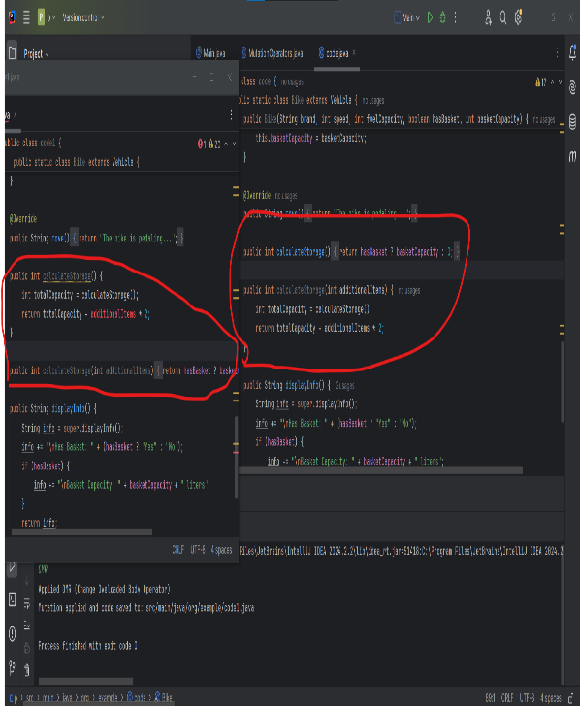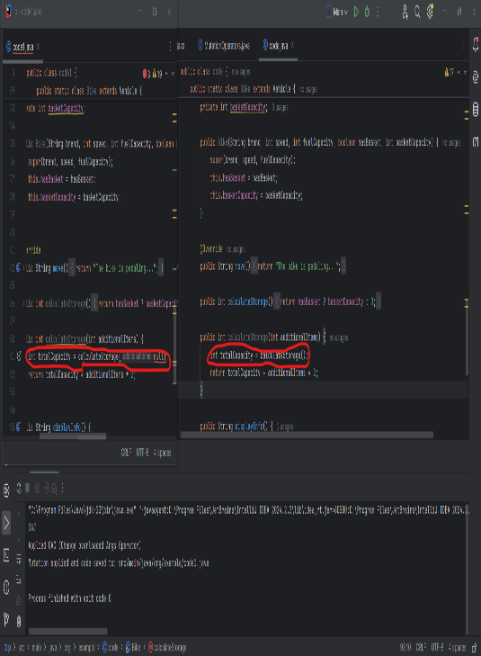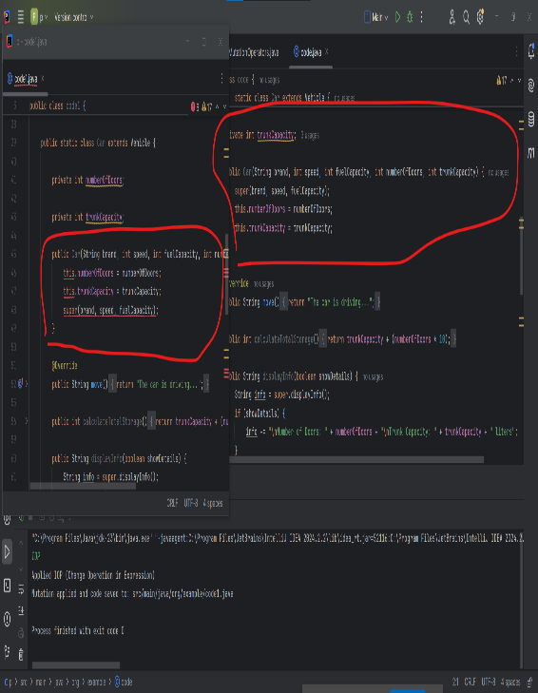

|  |
| --- |
|  |

Fig. 2. Examples of mutation

* 1. *Mutation Diversity*

The mutation generation process leverages the AST, allowing the creation of a diverse set of mutations. Unlike traditional mutation testing tools, which rely on predefined mutation operators, our approach dynamically generates mutations by analyzing the code's syntactic structure. This method enables the detection of a broader range of potential faults, many of which could not be generated using conventional mutation operators. Despite some limitations in our initial implementation (e.g., limited grammar for structural mutations), the results showed that the range of mutations produced could significantly enhance fault detection capabilities.

* 1. *Flexibility and Fault Injection Efficiency*

Our method's flexibility stands out, as it allows mutation customization based on the code’s specific features. The mutation process is controlled by selecting specific elements in the AST (such as integer literals, Boolean expressions, etc.), ensuring that only relevant parts of the code are mutated. This customization makes the method adaptable to a variety of software projects, particularly those with algorithmic or arithmetic components. We tested the method using several algorithms, such as binary search, bubble sort, and Dijkstra’s algorithm, to assess its fault injection capability. The resulting mutation score was 79%, compared to 70% for the baseline tool PIT. These results highlight the method’s efficiency in injecting meaningful faults. Our mutation testing approach includes a robust evaluation of its ability to inject meaningful faults into the code, assessed through a mutation score. This score is calculated using the following formula:



1. *Discussion*

Our approach[1] provides several advantages over traditional mutation testing methods:

* 1. **Language-Agnostic Approach**: The method is not tied to a specific programming paradigm, which makes it suitable for object-oriented, procedural, and functional languages alike. This ensures its wide applicability across different types of software projects.
  2. **Enhanced Mutation Variety**: By utilizing Java Parser’s AST, our approach allows for fine-grained control over the mutation process. This enables the generation of mutations that are tailored to the specific needs of a project, significantly improving the testing process.
  3. **Syntactic Integrity**: The use of AST parsing ensures that all mutations preserve the syntactic structure of the code. This results in realistic and meaningful faults that more accurately represent potential errors in software development.
  4. **Customizable Mutation Criteria**: Users can specify the types of mutations to be applied, such as arithmetic mutations or changes to Boolean logic. This level of customization improves the relevance and effectiveness of mutation testing, allowing developers to focus on critical areas of their code.

1. *Conclusion*

This paper presents a novel mutation testing approach based on Java Parser’s Abstract Syntax Tree (AST), offering enhanced control over mutation generation and improved fault detection. By leveraging AST parsing and mutation customization, our method provides a powerful tool for identifying potential issues in code. Additionally, integrating more advanced static analysis techniques could further improve the quality and accuracy of the mutations, providing even more reliable insights into code robustness.

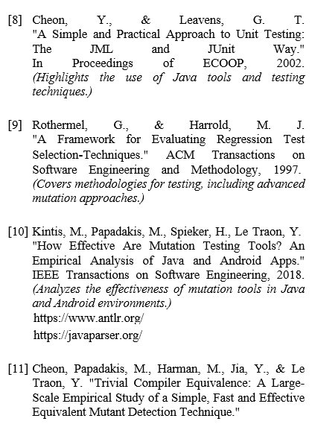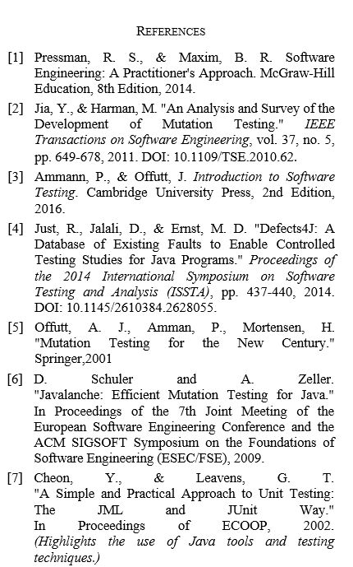

1. https://github.com/M-Amin-Kiani/JavaParser-for-OOCode-with-AST